SYNOPSIS

Name of the College : MVPS'S Rajarshi Shahu Maharaj Polytechnic Nashik
Name of the Course : Computer Technology
Name of the Group Members : 1. Pushpak Shrikant Wani
2. Omkar Vitthal Savant
3. Nikita Keshav Walke
Group-9
Name of Guide : -
Proposed Project Title : Online IEEE Paper Generation System

A] Project Description/Definition :
In the process of Online IEEE paper generation System, a large number of technical IEEE papers are written and used. The Online IEEE paper generation system is the final result of the survey and is a crucial basis for related IEEE paper and construction. It has become an urgent demand to effectively manage and automatically prepare research paper through automatic Online IEEE paper generation systems. The realization of these systems needs to first develop the key technology of automatic generation of IEEE papers, such as template customization, template storage, data filling, and programmatic generation. The Online IEEE generation System that can automatically be computer generated is a kind of professional field document with strong standardization. In that system we make Research paper and also download the Pdf File

B] Present Theories and Practice used/Literature Survey:
The system performs many tasks in fasted way without any complexity. The question paper generation system uses Research paper Format. In that enter the data by research paper format vise Manual generation of Research paper by an individual is complex, a simple and efficient way for generating research papers is automatic Online Research paper generation system.

C] Scope:
Online IEEE paper generation System is designed keeping in mind with many future possibilities that can improve the software to be more productive and easier The methodologies that we presented for generating IEEE paper show promising outcomes and can be utilized as a basis for making a more advanced automatic and independent paper generator .With the large database security threats are a major concern. To avoid this, a more secure database can. also be achieved, which will make sure that only an authorized person can have access to this system .Our effort is to develop this system for students such. This will be beneficial to the students as they are more inclined to solve multiple papers. With all these possibilities, this system will be more secure and will also provide much better results.

D] Objectives:
Our system aims to provide fast operations, data storage and high security for all its tasks. Online IEEE paper generation System automatically generates paper, prepares doc file as per selected paper format.

E] System Overview: with block diagram

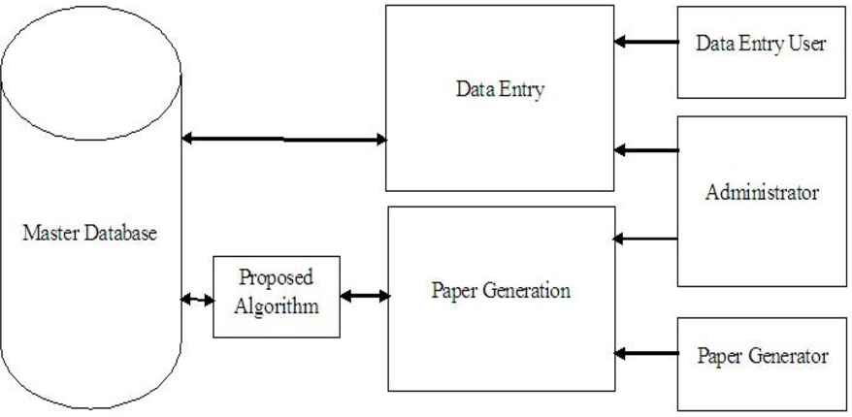

F] Implementation Details:
System Requirements:
1] Hardware (Minimum)
- Processor : Intel core i3
- Ram: 2 GB (min)
- Hard disk : 64GB

2] Software
- Operating System: Window 7.
- Front End: Bootstrap4,css,Html
- Back End: MySQL, PHP
- Code editor: Visual Studio, Sublime text

G] Conclusion:
This system platform is very secure and also faster because it is computer and web-based system. This system is web-based system and also computer based. In this system, we have implemented randomized process so avoid the incorrect paper format. This system represents for generating automation in IEEE paper process as the real-time application. with the help of system easily generates automatic ieee papers and improvement from the traditional method of paper generation

H] References: IEEE Format
[1] Xiang Fu, Boris Peltsverger, Kai Qian, Lixin Tao, Jigang Liu,” APOGEE –Automated Project Grading and Instant Feedback System for Web Based Computing”, Computer Science and Information Technology, 2nd IEEE International Conference 2009.

[2] Challenged and Implications for Pre-Service Teacher Educaion”, Annual Conference of the International Association for Educational Assessment (IAEA) held at the Dan Panorama Hotel, Tel-Aviv, IsrealOctober 20th –25th, 2013

[3] M. Jou,J.K. Shiauand H.W. Zhang,”Application of Web Technologies in Automationon Technology Education”, International Journal of Computers and Applications, Vol.31, No. 4, 2009

[4] Automatic Question Generation using Discourse Cues by Manish Agarwal_, Rakshit Shah_ and Prashanth Mannem

[5] Automatic Cloze-Questions Generation by Annamaneni Narendra, Manish Agarwal and Rakshit shah LTRC, IIIT-Hyderabad, India

Web Reference:
- https://www.w3schools.com/
- https://www.geeksforgeeks.org/

Student Guide Name &sign of staff HOD

